MONDAY | TUESDAY | WEDNESDAY | THURSDAY | FRIDAY
4  Pray for all the new farm animals that will be born this springtime | 5  Pray that Year 6 have been allocated their schools of choice | 6  Pray for fairtrade and people who work for little pay | 7  Pray for all the wonderful books we have access to in our school | 8  Pray for mums and those who take on that role
11  Pray for all members of the commonwealth who share our same king | 12  Pray that we continue to think about being kind | 13  Pray for all the Good Samaritans in our world | 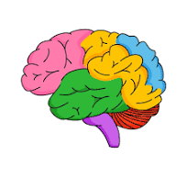  14  On Genius Day, pray for the gift of thinking | 15  Pray for those in the world less fortunate than ourselves
18  Thank God for our beautiful school | 19  Pray for all our volunteers | 20  Give thanks for the first day of spring | 21  Pray for all the wonderful colours in the world | 22  Pray for friendship and happiness
25  Pray goodness over evil in the world | 26  Pray for anyone in our community who is ill | 27  Remember Jesus as we approach Holy Week | 28  Pray for all our families that they have a peaceful Easter time | Good Friday
Easter  Holidays | Easter  Holidays | Easter  Holidays | Easter  Holidays | Prayer Calendar

