MONDAY | TUESDAY | WEDNESDAY | THURSDAY | FRIDAY
3  Half term | 4  Half term | 5  Half term | 6  Half term | 7  Half term
10  Pray for Y1 for their phonics test | 11  Pray that we are Good Samaritans and show empathy to others | 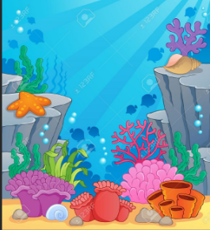  12  Pray that we recognise threats to our oceans | 13  Give thanks for the month of June | 14  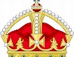  Pray for the King on his official birthday
17  Pray for dads around the world | 18  Give thanks for our loving school community | 19  Pray for freedom and a kind world | 20  Give thanks for the sun on the longest day | 21  Give thanks for all the wonderful music in our world
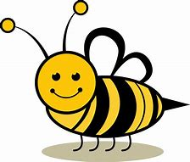  24  Pray for our honey bees as they are busy collecting nectar | 25  Pray for all crafters on LEON Day | 26  Give thanks for our physical health on sports day | 27  Pray for friendship on National Handshake Day | 28  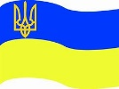  Pray for Ukrainian Constitution Day
29  Pray for all our Armed Forces | 30  Pray for all those in our community who are ill | Prayer Calendar | 