MONDAY | TUESDAY | WEDNESDAY | THURSDAY | FRIDAY
 | 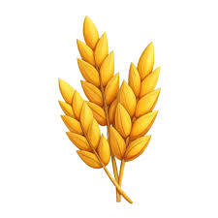  1  Give thanks for our food at this Harvest time | 2  Pray for all those who are caught up in conflict | 3  Pray for those in our community who do not have enough food | 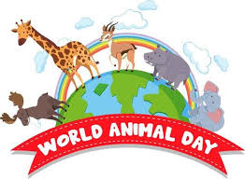  4  Pray for our animals on world animal welfare day
  7  Pray for Miss Hawkins on her birthday | 8  Pray for all our teachers on world teachers’ day | 9  Pray Jewish people on their festival of Yom Kippur | 10  Pray for Reverend Adelle as she becomes our new vicar | 11  Pray for all our pupils and staff born in October
14  Pray for all children around the world |   15  Pray for animals who will be hibernating shortly |   16  Give thanks for the authors of our favourite books | 17    Thank God for the Sun Earth and Moon | 18  Pray for our duvet winners
21  Pray that we know how to show consideration and kindness | 22  Pray for all the working animals who support humans | 23  Give thanks for our school and all those who attend it | 24  Keep us all safe during our half term |   Prayer Calendar

